Frequently Asked Questions (FAQ) Received through SMS@dot.state.oh.us
- How do I get a username and password (05/13/2014)?
Step 1: Non ODOT employees: Sign up for an Active Directory Account if you do not already have one, through the "MyODOT" link below according to the User Manual, Go to MyODOT link and choose a Basic Account. Fill out all of the information and clearly identify whether you will serve as a Control Authority, Program Manager, Team Leader or Team Member in the Title block.
Step 2: If you already have a MyODOT account then simply email SMS@dot.state.oh.us a request to add SMS to your already active MyODOT account. We will add SMS to your account.
Step 3: Wait until an email is sent to you with your username and password
- I am a consultant. How do I get bridges into my SMS profile in order to inventory and inspect (05/13/2014)?
Consultants who are awarded contracts will have to get the control authority for the District, County or Municipality to send SMS@dot.state.oh.us an email requesting all, several or a few bridges to give to the consultant. This process will eventually be formalized but until then an email with the approval of the public entity will suffice.
- Will there be an SMS manual (05/13/2014)?
Yes, it is being developed by the vendor and it will be embedded within SMS help functions. A version is already available in the smstest site under the 'Help' function and is uploaded to the ODOT SMS website.
- Will there be an new Inspection Manual (05/13/2014)?
Yes, it will be released when SMS goes live. The draft version is already available in the smstest site under the 'Help' function and on the ODOT Bridge Inspection & Maintenance website.
- Will there be additional training on the SMS (05/13/2014)?
Yes, video tutorials are being developed to guide users through common functions of the SMS system. These are viewable from this website or the SMS YouTube channel. Additional training needs will be considered.
- What is the URL of SMS Update page (05/13/2014)?
The SMS Updates are available on SMS Update page which located at ODOT Home>Divisions>Engineering>Structural Engineering>Structure Management System (SMS). The URL of the SMS Update page is http://www.dot.state.oh.us/Divisions/Engineering/Structures/Pages/Structure-Management-System.aspx)
- What is the URL of SMS Test Site (05/13/2014)?
https://smstest.transportation.ohio.gov
- What is the URL of SMS Production Site (05/13/2014)?
https://sms.transportation.ohio.gov
- What is the URL of ODOT FTP Site for downloading Offline Version (05/13/2014)?
ftp://ftp.dot.state.oh.us/pub/Structures/BMS/Web_download_files/
- Where are the SMS videos posted on You Tube (05/13/2014)?
https://www.youtube.com/channel/UCn2r5ZtyvrOxWW4j92mYFQg
- What is the Email address to send suggestions & questions about SMS (05/13/2014)?
sms@dot.state.oh.us
- Are on-line and off-line passwords in SMS same (05/13/2014)?
SMS has two passwords: On-line password and Off-line password. Both passwords are case-sensitive, and different. It is a good practice to keep them different and not to mix them up. Your On-line password is through ODOT active directory and it may expire according to the rules set in the active directory. Your Off-line password is in the SMS application and it does not expire.
- How to reset my off-line password (05/13/2014)?
You can set your offline password by going to SMS on-line and selecting My Account on Main Menu.
- If I have forgotten my on-line password, how can I reset it (05/13/2014)?
For ODOT users, the SMS online password is the same as your windows network password.
For non-ODOT users, got to My ODOT page to reset your SMS on-line password.

- How do I put my P.E. into a report (6/2/2014)?
Add your P.E. number before you do your first review. This is currently the only way to place your P.E. number on the inspection report.
Relevant Video: https://www.youtube.com/watch?v=jIgM4xHW9sE
STEP 1: Log into SMS and go to MAIN > My Account
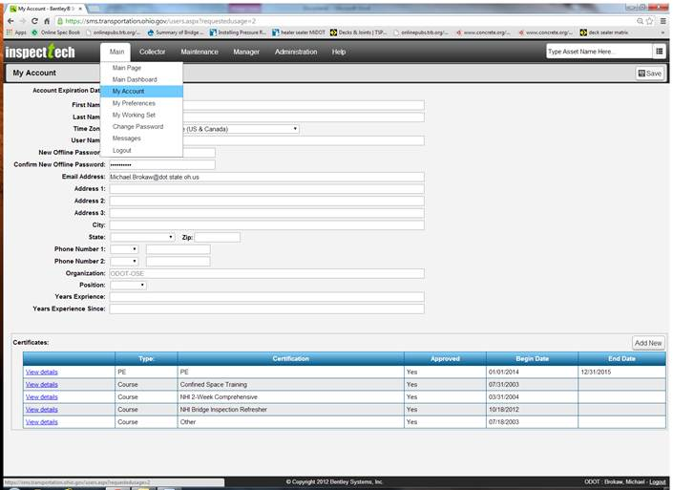

STEP 2: Under Certificates select “Add New”
STEP 3: Fill in the text boxes from top to bottom ensuring your P.E. number is entered correctly in the “License Number”. Upload the P.E. certificate if you choose.
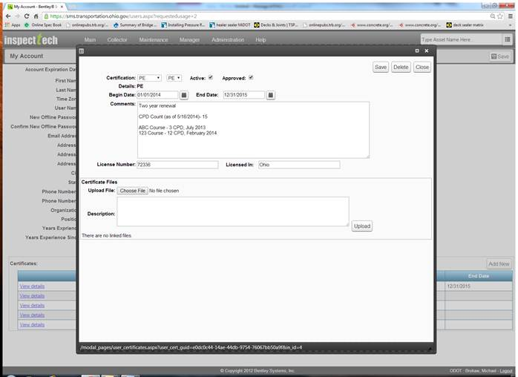
STEP 4: Start Reviewing. Easiest place to review is from Collector>Report Filter site. You can set this as your default page when you login under Main>My Preferences and edit the last row to ‘Report Filter’.
Relevant video (same as above): https://www.youtube.com/watch?v=jIgM4xHW9sE

- What is a good methodology for inspection online when doing a whole route?

- Create Report and make your updates and don’t submit for review quite yet
- Select the Triangle Icon in the top right hand corner
- It takes you to all of the bridges on the route
- Select the wrench to ‘Submit Report for Review’ or just submit whenever you want (these can most-easily be accessed by Collector>Report filter and pull up your ‘In Progress’ reports, you can customize your own filters)
- Select the next bridge on the route and repeat

- I am doing an element level inspection, how do the quantities relate?
In order to update quantities I ‘create’ a report and begin with approach items and do the following:
- First go into the Inventory Shortcuts, look for the white boxes and update them to what they quantities should be (will be in future, for example for Embankment I make ‘4’ because we will update only the text to say Embankment ‘count’).
- Second I hit F5 or ‘refresh’ to see my updates.
- Third I go into the ‘Total Quantity’ box and refine the value. If it is a quantity that I need removed I highlight the quantity and either ‘delete’, ‘backspace’ or type ‘0’.
- Fourth I refresh again to verify my changes.

This is how CS and Total Quantities relate:
- Total Quantity = Equations from the Inventory Shortcuts OR What you type directly into this field (when you type in the field it forever removes the equation)
- CS1 = Total Quantity – (CS2 + CS3 + CS4)
- CS2 = whatever you type into the box
- CS3 = see CS2
- CS4 = see CS2
- Transition Rating = Read Only, Weighted Average Equations behind the scenes and only intended to help the inspector not hinder.

